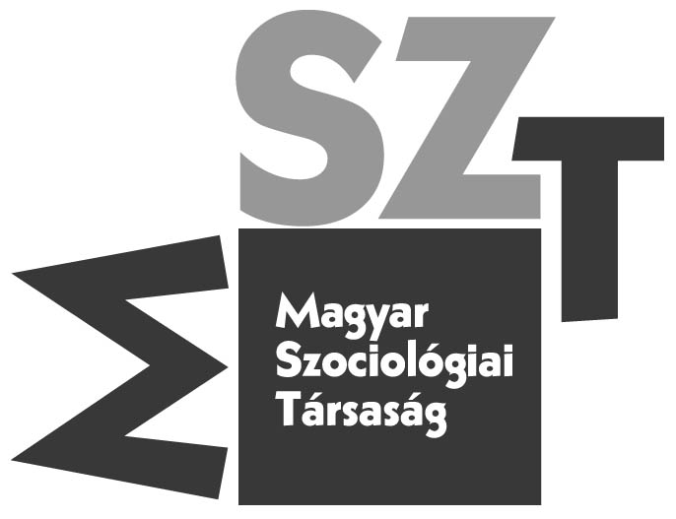

Hungarian Sociological Association

CONFERENCE IN MEMORY OF THE CENTENARY BIRTHDAY
OF SÁNDOR SZALAI
25th October, 2012

Venue: H-1014 Országház St. 28. Erzsébet Room, Budapest, Hungary

9.00 – 9.30 Exhibition opening
9.30 – 9.40 Welcoming Remarks: by György Csepeli, president of the Hungarian
Sociological Association

Historical Strikes
Chair: Ildikó Szabó

9.40 – 10.10 Pál Péter Tóth:Some contributions to Sándor Szalai’s Biography and
Professional History
10.10 –10.40 Tamás Csapody: Sándor Szalai and the Forced Labor in Bor
10.40 –11.10 Éva L. Gál: Szalai: “the lighthouse of ideological sabotaging”
11.10 –11.40 György Földes: The Time Sándor Szalai Lived in Kadar’s Hungary

11.40- 11.50 Coffee break

Sándor Szalai and Statistics
Chair: Béla Janky

11.50 – 12.00 Zsuzsa Ferge: On Some Aspects of the International Time Budget
Survey of 1964
12.00 – 12.30 Béla Falussy: Time Budget Research in the 2000s
12.30 – 13.00 István Harcsa: Sándor Szalai’s “remonstrance” for Statistics

13.00 – 14.00 Lunch break

The Professor, the Researcher, the, Manager of Academic Affairs
Chair: Mihály Csákó

14.00 –14.30 Péter Somlai: Literacy and Expertise
14.30 –15.00 Pál Tamás: Sándor Szalai, Manager of Academic Affairs
15.00 –15.30 Imre Kovách: Sándor Szalai’s Influence on Social Research

15.30 –15.40 Coffee break

15.40 –17.00 Closing Remarks and Reception

______________________________________________________________________________
H – 1014 Budapest, Országház utca 30.
Tel: (06)-70-624-77-04
e-mail: mszt@socio.mta.hu

